Overview

Device | Port | IP /30 (+ /24 LAN) | Role
PC1-1 | e0 | 192.168.10.2/24 | Client A
Cisco1 | e1/1 | 192.168.10.1/24 | LAN A
 | e1/0 | 172.16.0.1/30 | WAN A
R1 | e0/0 | 172.16.0.2/30 | Connects to Cisco1
 | e0/1 | 172.16.0.5/30 | Connects to pfSense
pfSense-1 | WAN | 172.16.0.6/30 | WAN B
 | LAN | 192.168.20.1/24 | LAN B
PC2-1 | e0 | 192.168.20.2/24 | Client B

Phase 1 (ISAKMP)
Exchange type Main mode
Authentication method PSK
Encryption algorithm AES-256-CTR
Authentication algorithm SHA-256
Diffie-Hellman group group 2
IKE session key lifetime 86400 s = 1 day
Phase 2 (IPSec)
IPSec Protocol ESP
Mode Tunnel
Encryption algorithm AES-256-CTR
Authentication algorithm HMAC-SHA-256
IPSec session key lifetime 3600 s = 1 hour
Perfect Forward Secrecy (PFS) group 5

Network diagram:
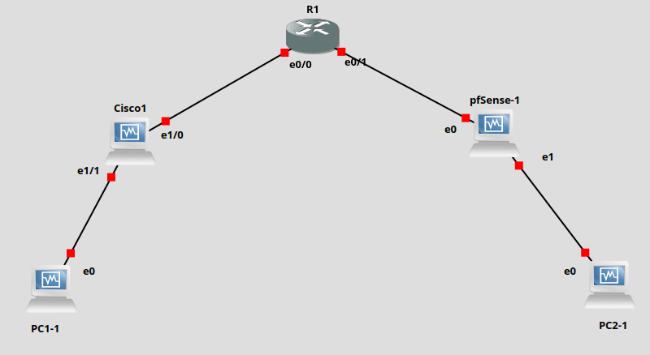

Network Lab Environment
- GNS3 và GNS3 VM: https://github.com/GNS3/gns3-gui/releases/tag/v3.0.5
- Router L3: https://github.com/obscur95/gns3-server/blob/master/IOU/i86bi-linux-l3-adventerprisek9-15.5.2T.bin
- iouLicense (Router L3) https://github.com/obscur95/gns3-server/blob/master/IOU/CiscoIOUKeygen.py
- Cisco: https://github.com/obscur95/gns3-server/blob/master/IOS/c7200-adventerprisek9-mz.152-4.S7.bin
- Ubuntu: https://ubuntu.com/download
- pfSense: https://www.pfsense.org/download/

GNS3
Server:
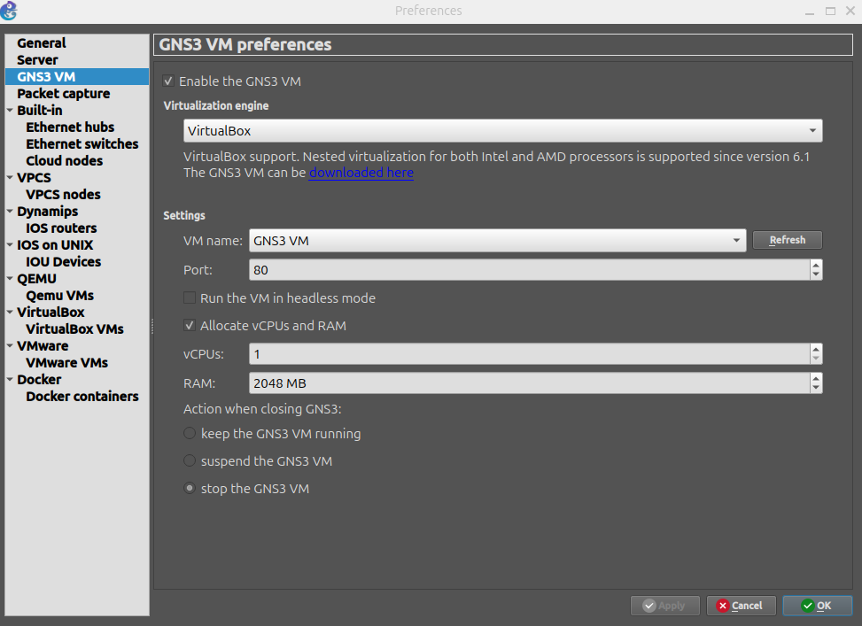

IOS:
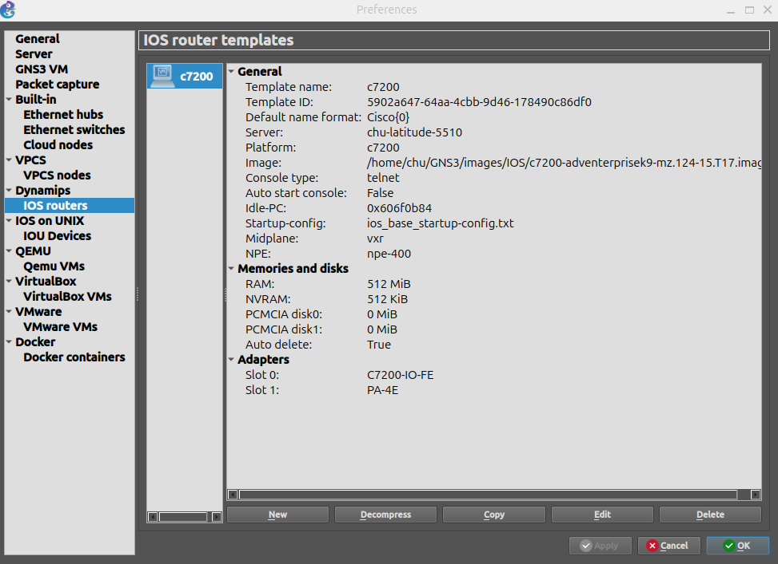
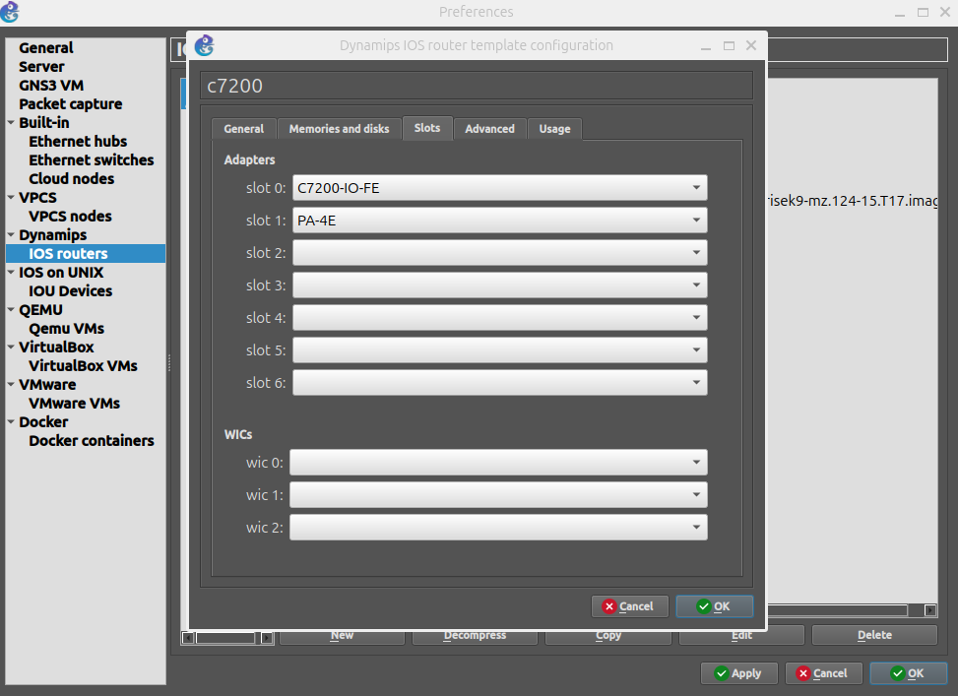

IOS:
add iourc file (licence)
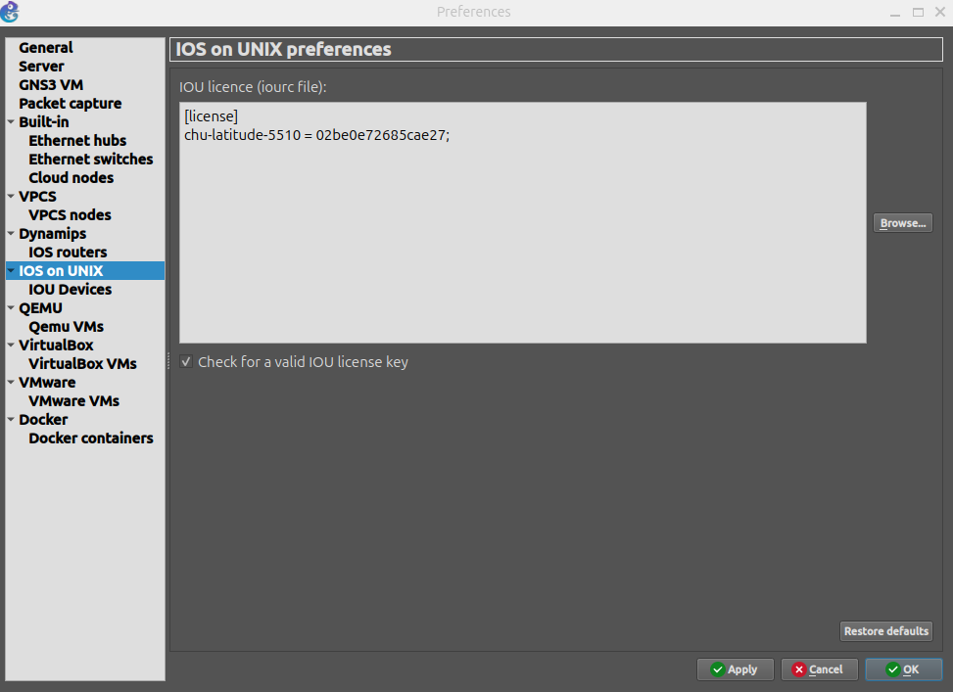
router
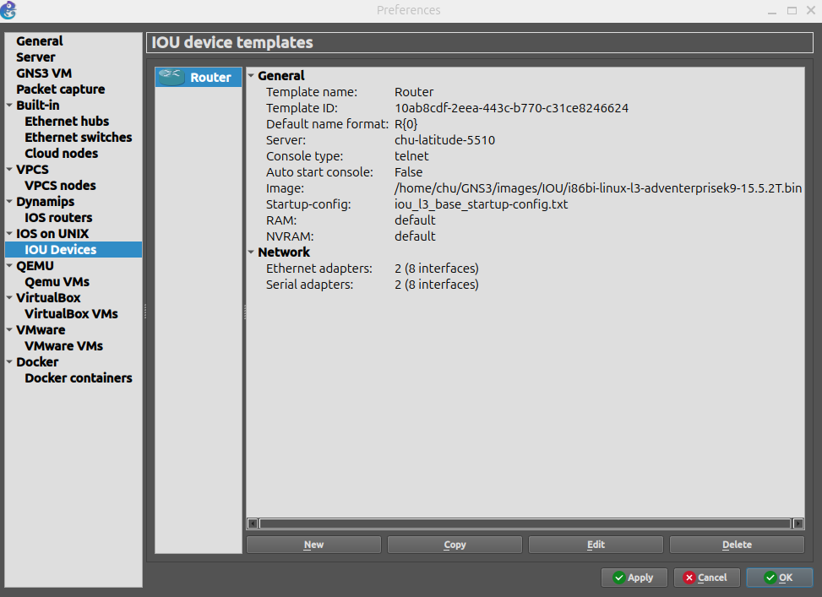

PC:
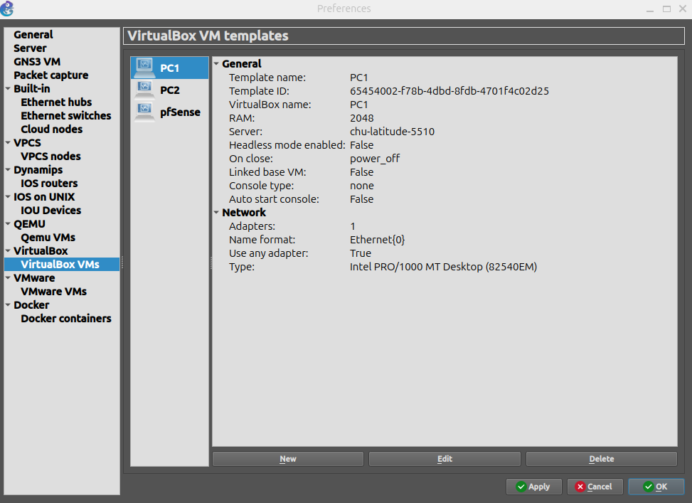
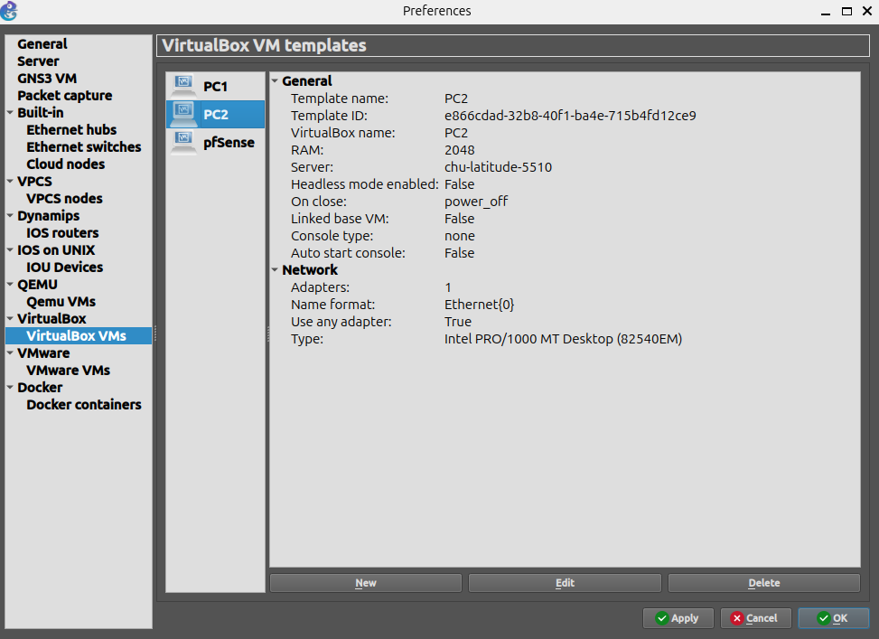
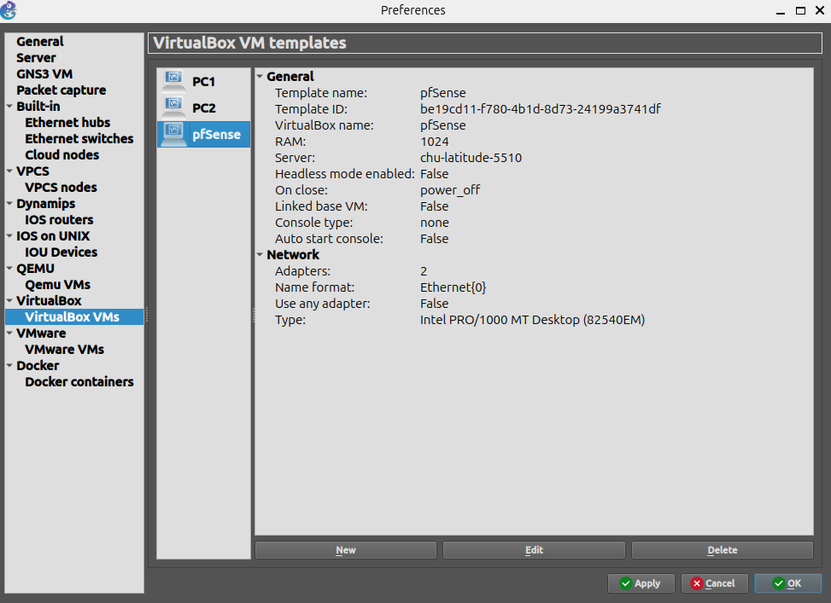

GNS3 VM
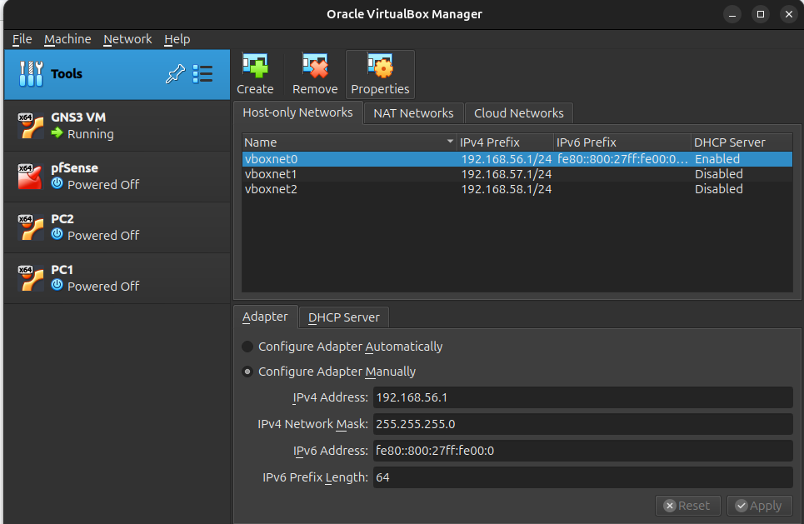
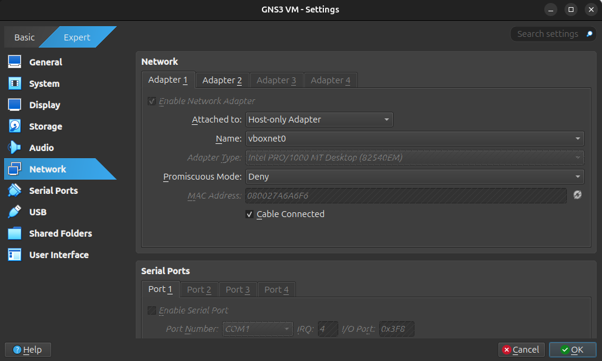

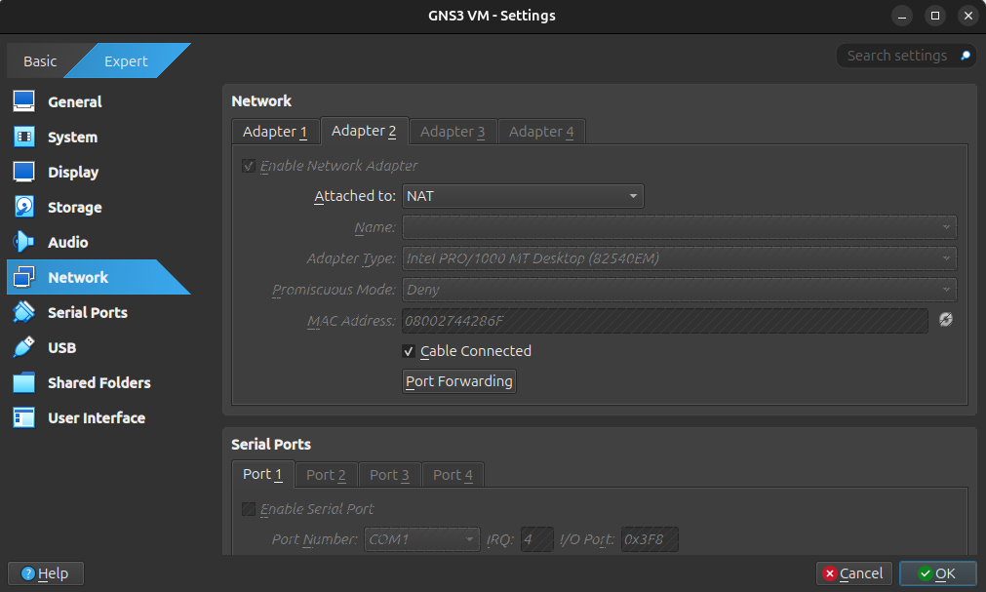
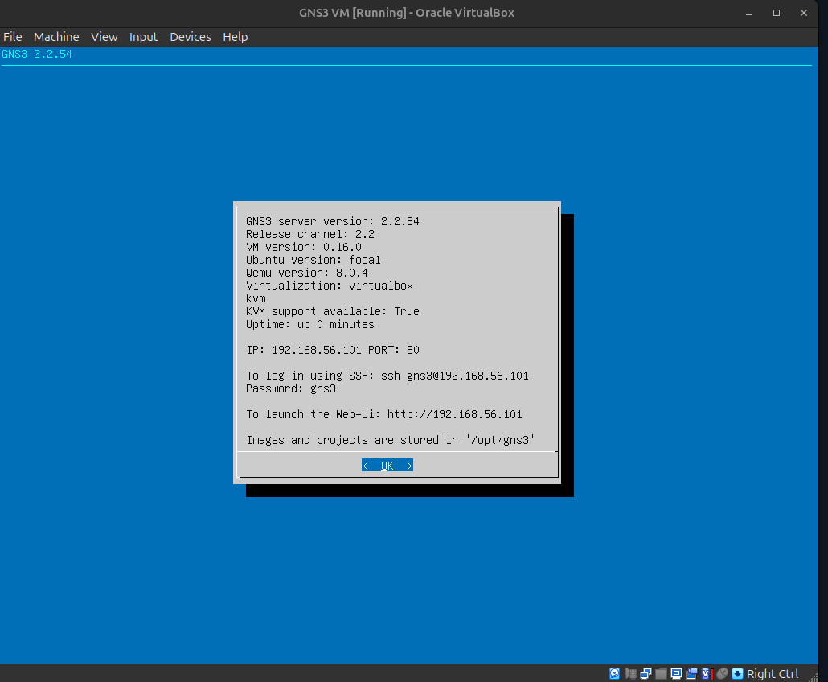

PC1 - Virtual Machine
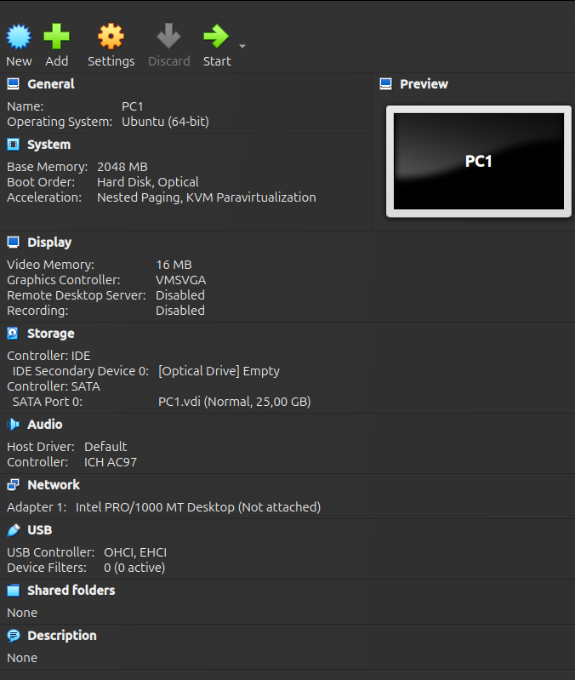

Install tools:
sudo apt update
sudo apt install -y net-tools iproute2 iputils-ping traceroute dnsutils curl wget
sudo apt install -y iperf3
sudo apt install -y tcpdump
sudo apt install -y openssh-server

IP configuration for PC1:
network:
version: 2
ethernets:
enp0s3:
dhcp4: no
addresses:
- 192.168.10.2/24
gateway4: 192.168.10.1
routes:
- to: 192.168.20.0/24
via: 192.168.10.1

PC2 - Virtual Machine
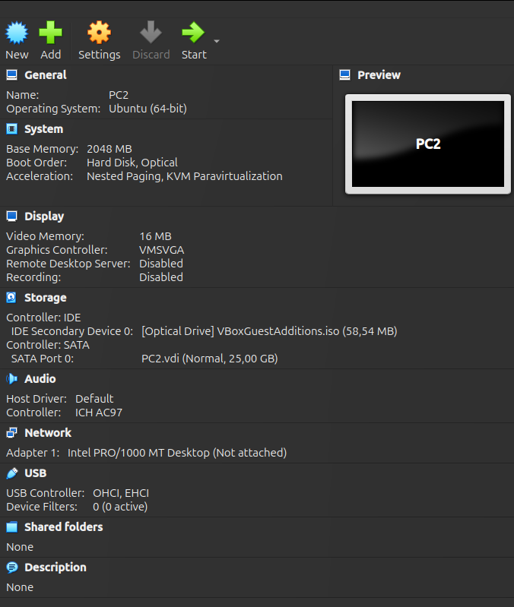

Install tools:
sudo apt update
sudo apt install -y net-tools iproute2 iputils-ping traceroute dnsutils curl wget
sudo apt install -y iperf3
sudo apt install -y tcpdump
sudo apt install -y openssh-server

IP configuration for PC2:
network:
version: 2
ethernets:
enp0s3:
dhcp4: no
addresses:
- 192.168.20.2/24
gateway4: 192.168.20.1
routes:
- to: 192.168.10.0/24
via: 192.168.20.1

pfSense
